RICEF

Reports

Interface

Conversions - to upload the data to databases,

Enhancements – adding the additional functionality to existing functionalities

Forms -

ABAP Dictionary

Int tables, work area

Open SQL

Subroutines

Function Modules

Out born

In born

Data Flow

T code -> SAP dB -> ABAP program -> Output

Smart Forms

SAP Smart Forms is used to create and maintain forms for mass printing in SAP Systems. Besides using the printer for standard output, you can also select the Internet (by using a generated HTML output), a fax, or e-mail as the output medium.

Form interface will interact with ABAP program to print the data in Smart form.

Global definition is the data types declaration

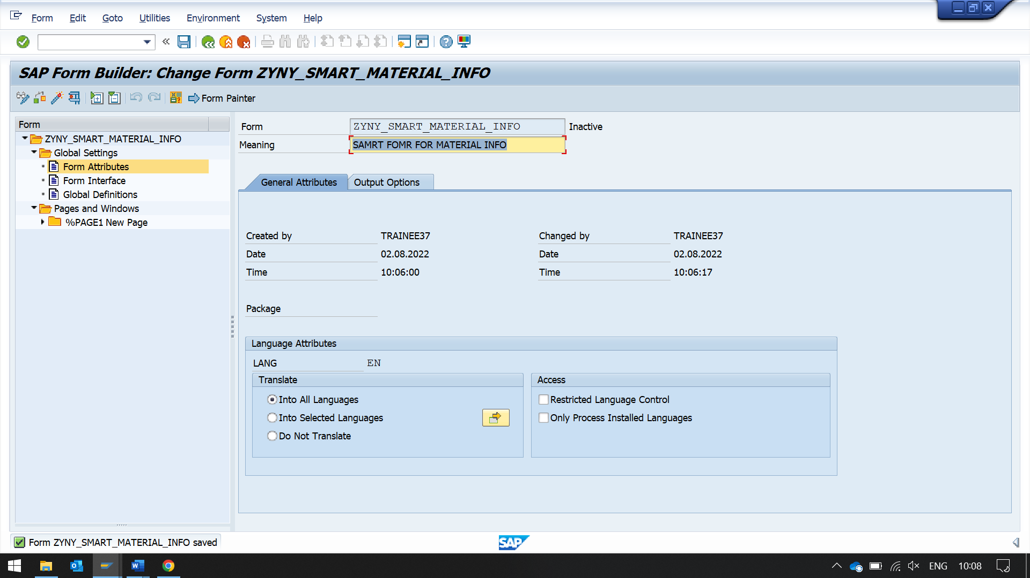

T code smart forms

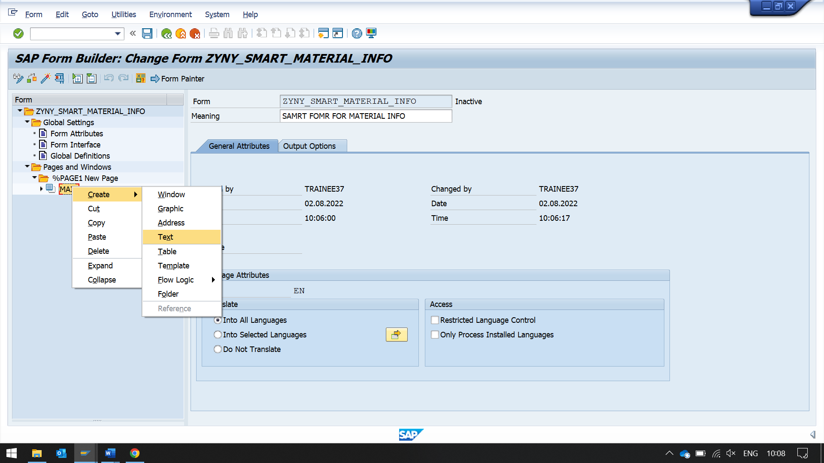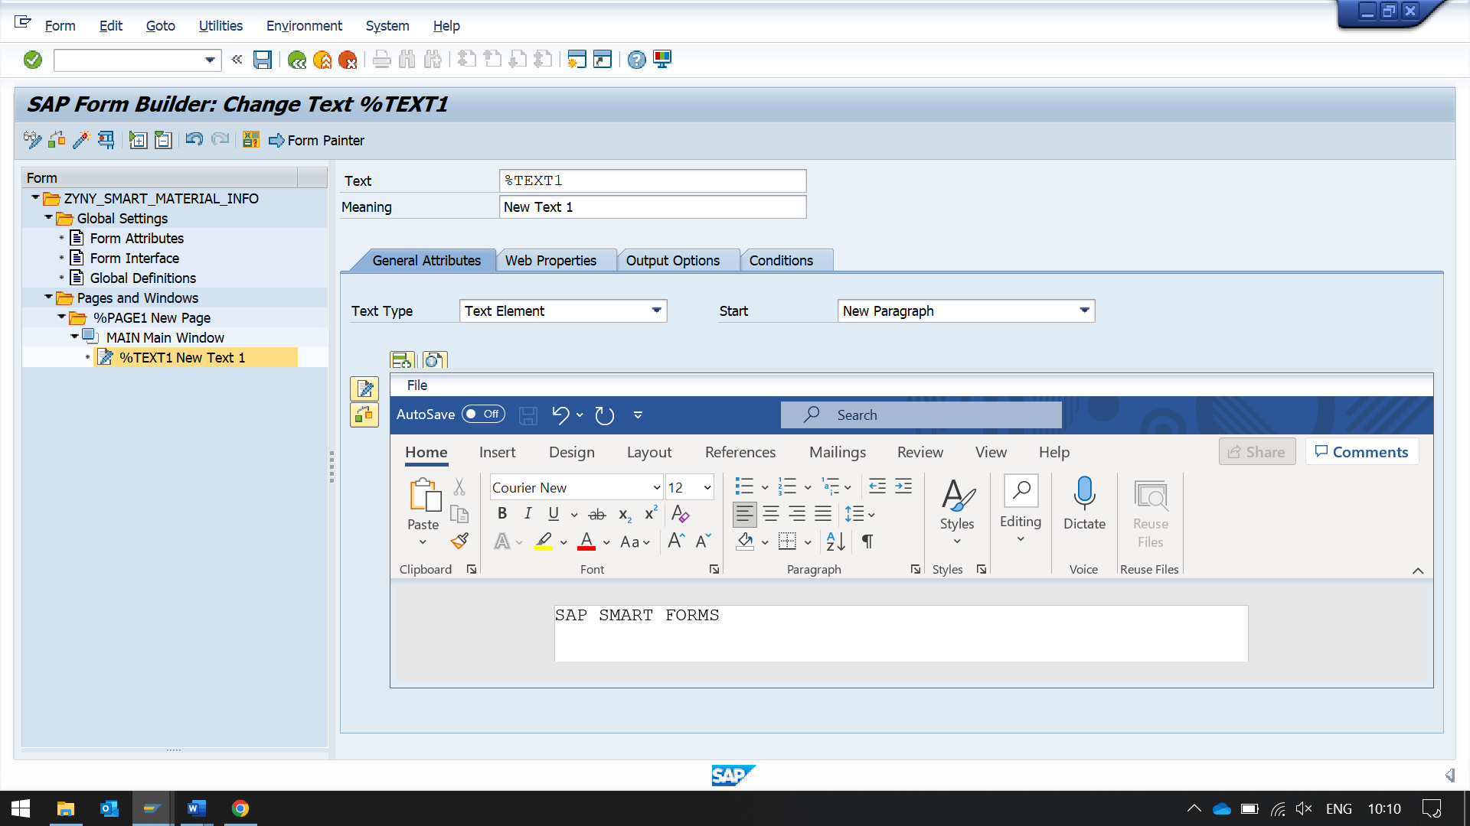

After saving and activating the form.

Then while executing it will create a new function module.

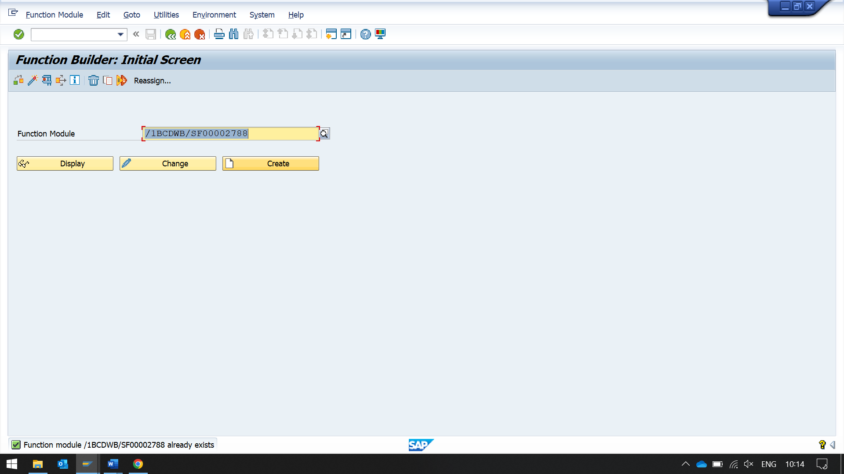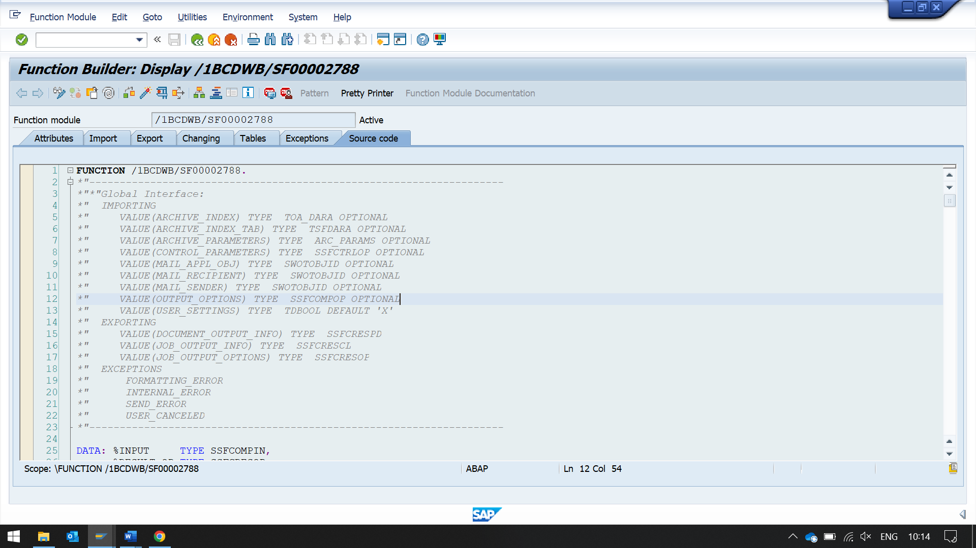

then execute.

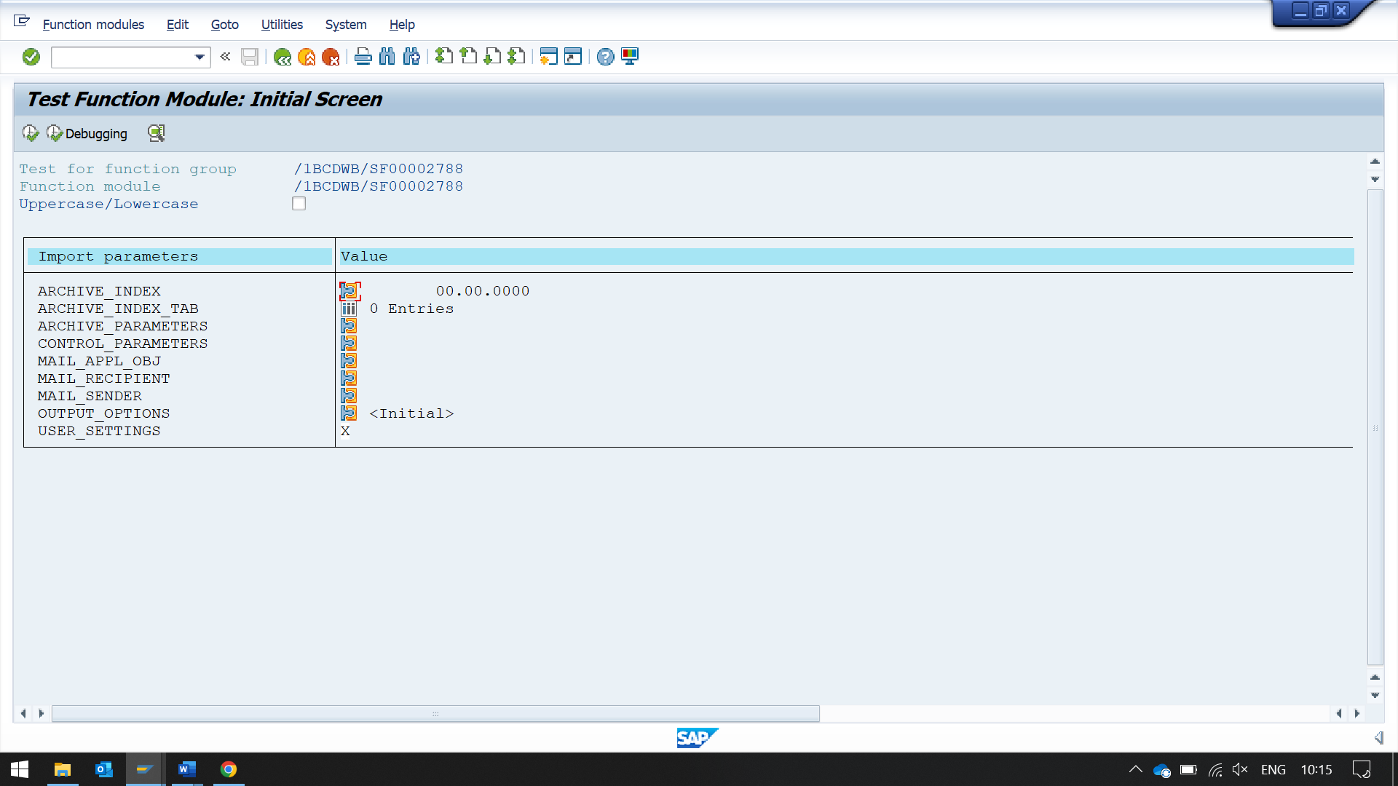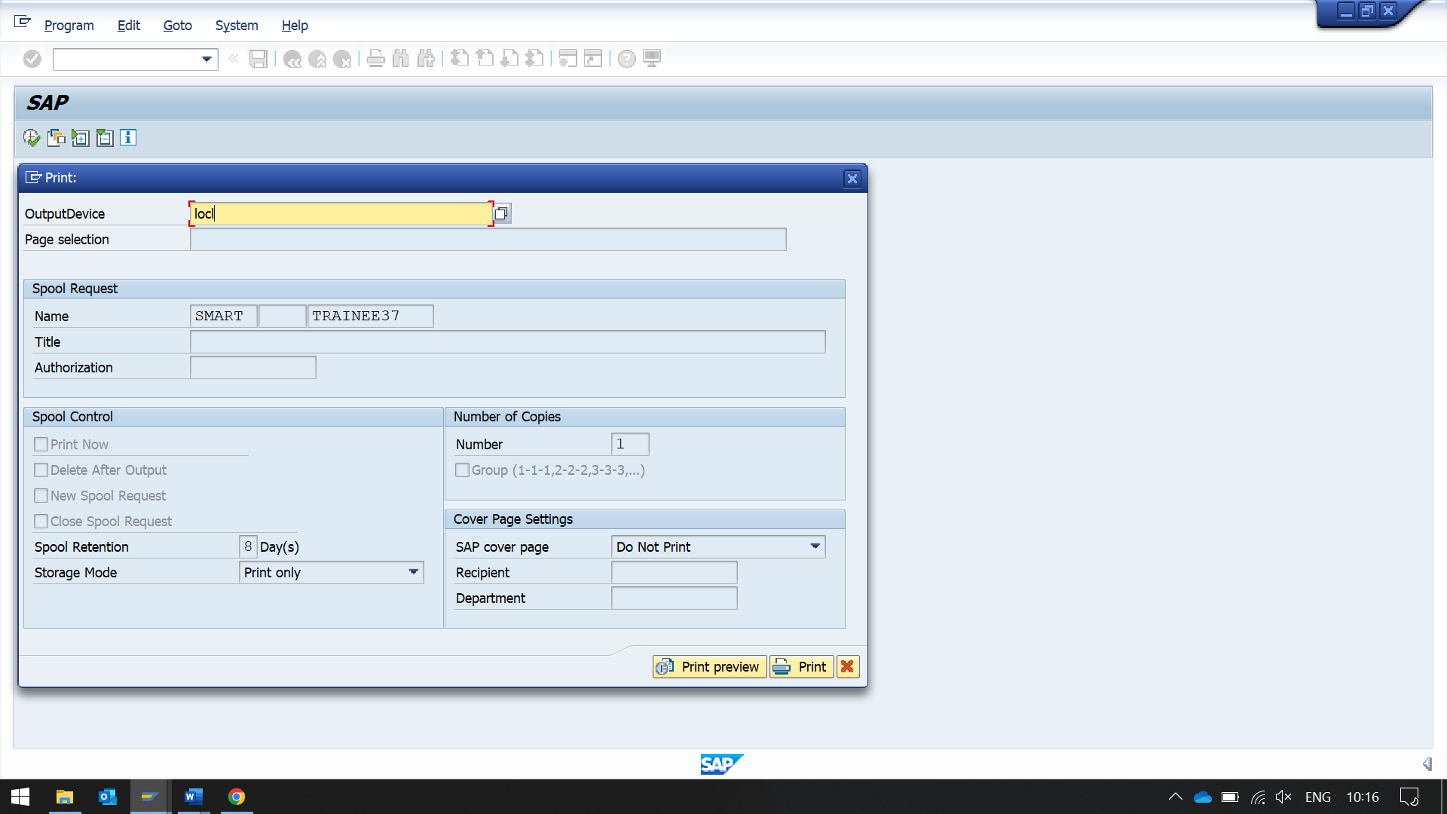

click on print preview

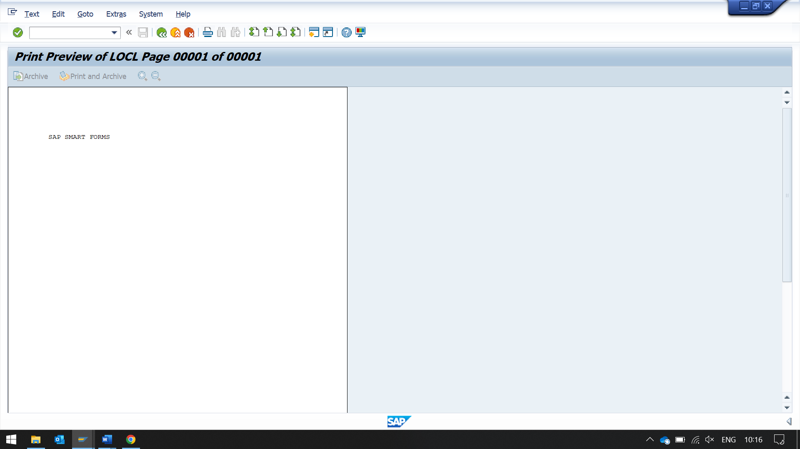

Now to upload logo to SAP,

T code - SE78

LOGO should be in bpm extension

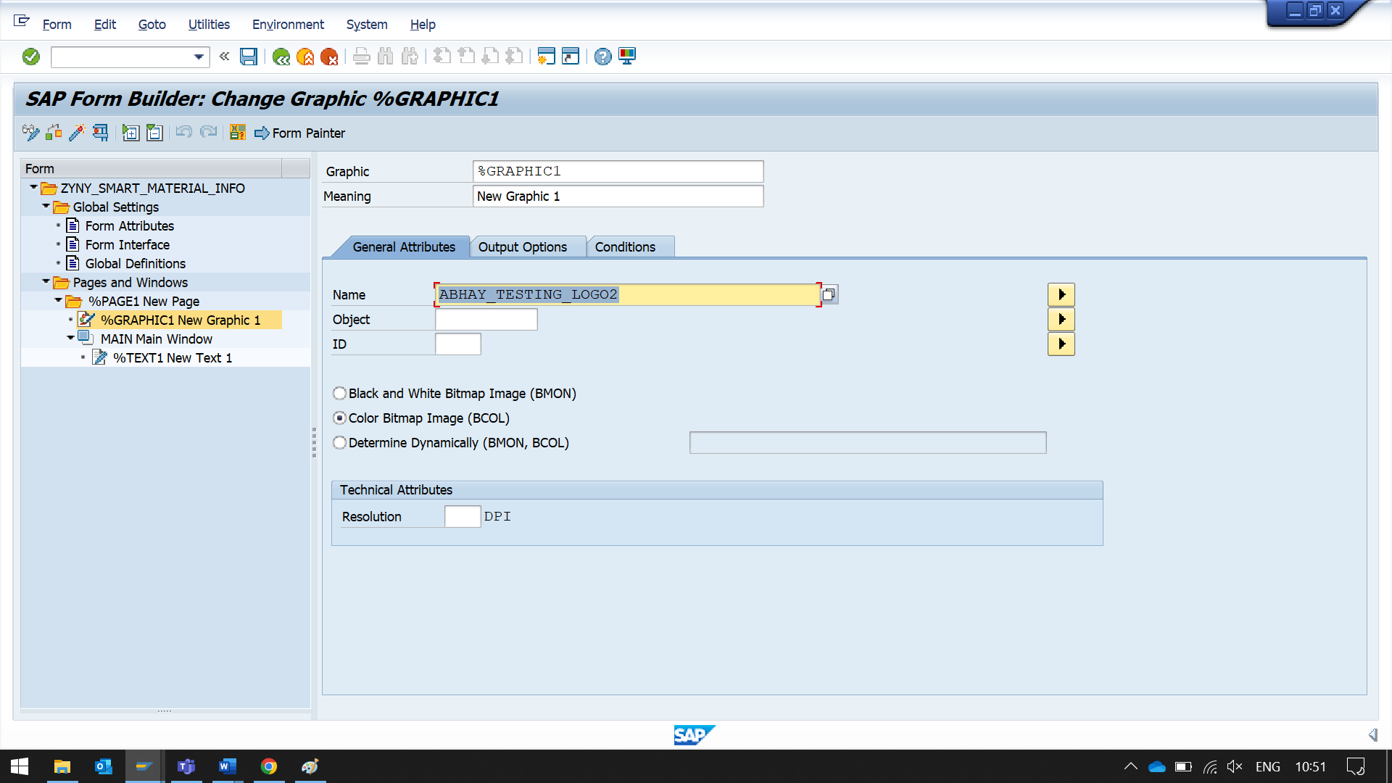

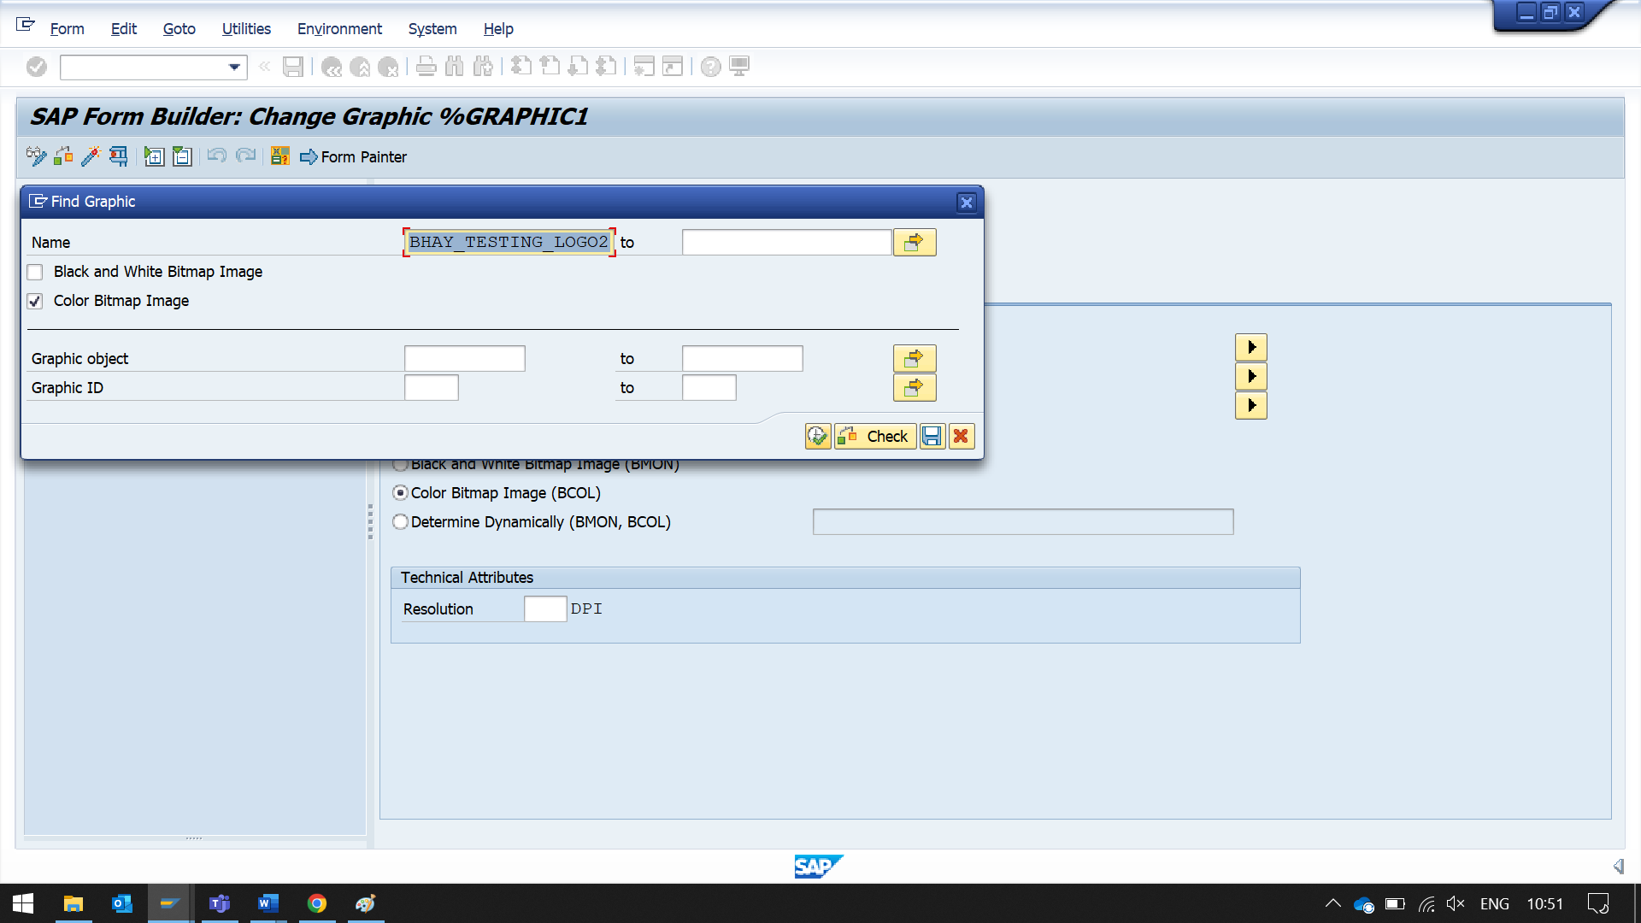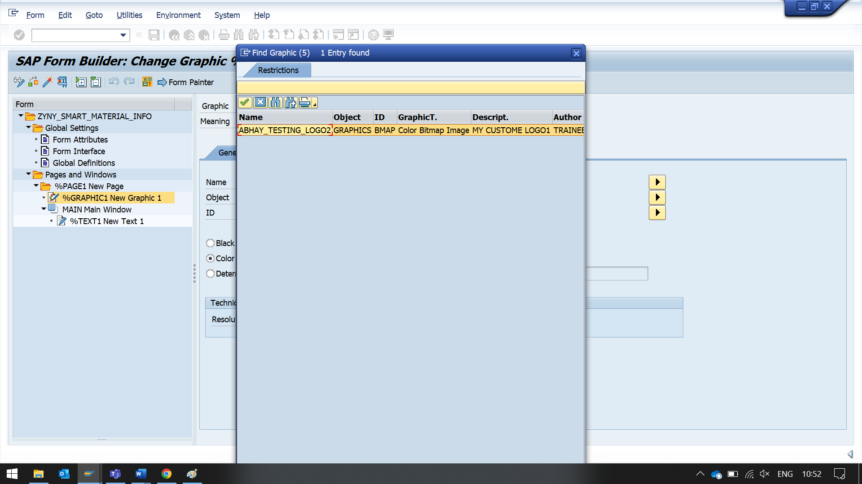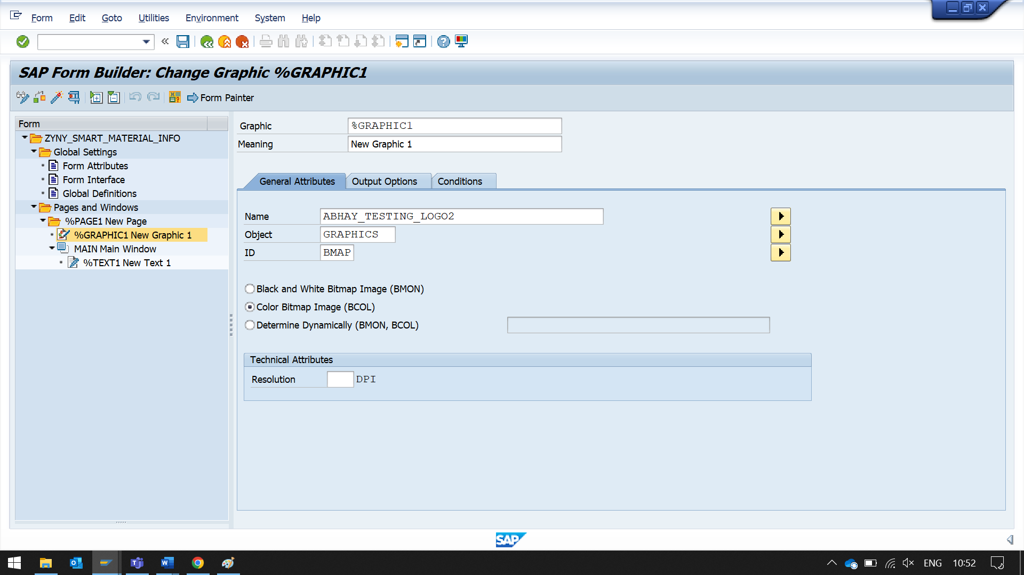

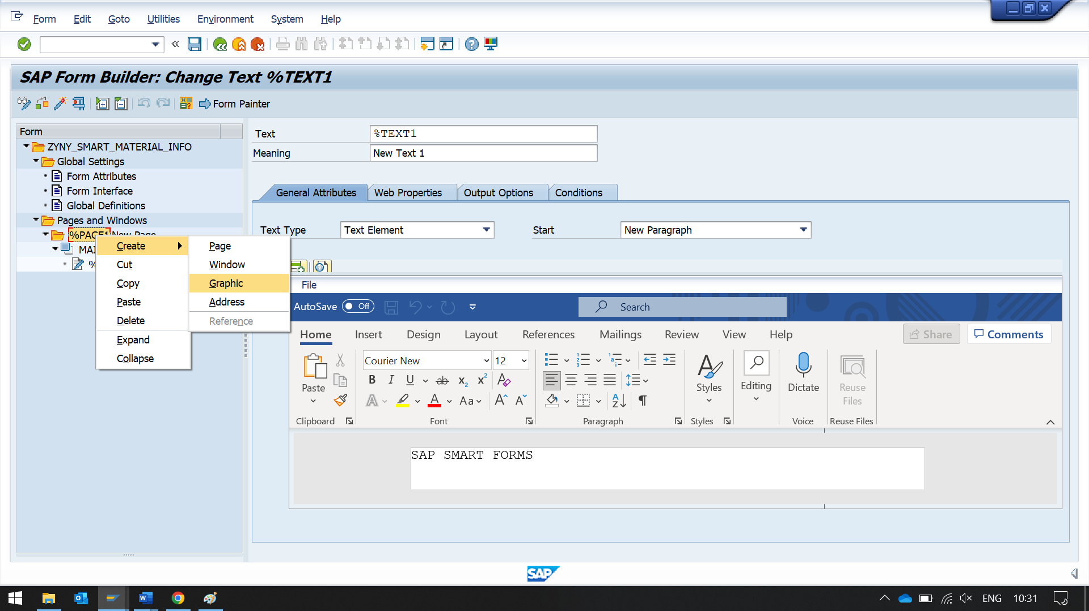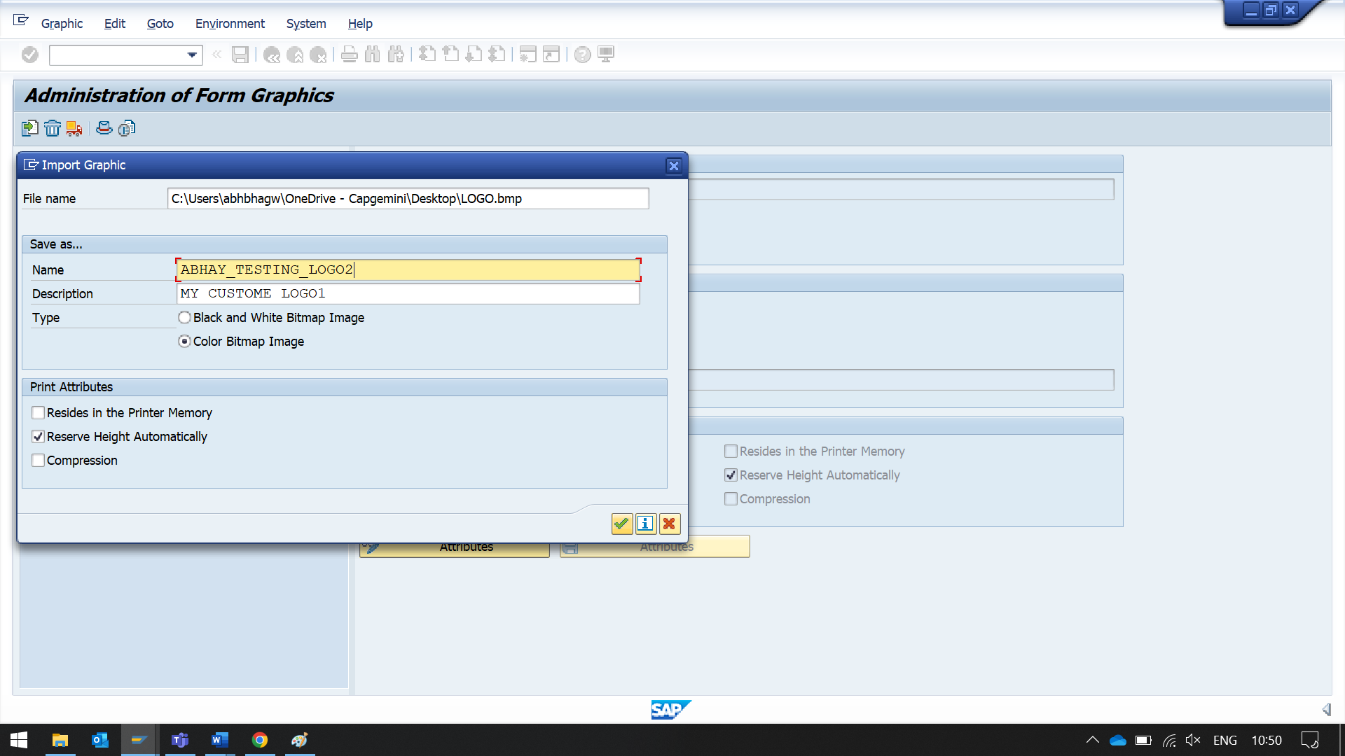click on the search help button to search for logo

enter your logo name

select your logo

then execute

Driver program / Print program - A Driver program is **An SAP report program used to call SAP script or SMARTFORMS**.

SF_EXAMPLE_01

**Answers: Subject: Difference between form interface and global definitions**

The Difference is as follows.

to put it very simply:

Form Interface is where you declare what must be passed in and out of the smart form (in from the print program to the smart form and out from the smart form to the print program).

Global defs. is where you declare data to be used within the smart form on a global scope.  
i.e.: anything you declare here can be used in any other node in the form.

Conversions – convert the data coming into SAPA system from legacy system and upload data into SAP system.

SAP DB

SAP TCODE

ABAP

PROGRAM

FLAT FILE

Data should update into the table using the tcodes.

When we use INSERT, UPDATE, MODIFY, DELETE Statements to update the data of the db tables but it is not recommended approach to update std db tables, instead of that we use BDC/Conversions to upload the data into SAP tables through the tcode so that the data integrity is maintained

BDC(Batch data communication)

We can use insert, update, modify, delete statements for our custom tables.

SM35

ABAP PROGRAM

BDC SESSION METHOD USES 3 STD FUNCTION MODULE.

TO UPLOAD THE DATA INTO SAP SYSTEM

THIS FUNCTION MODULE WILL CREATE A SESSION, THE NAME WE PASSED INTO THE FUNCTION MODULE.

FLAT FILE -> IT FILE -> SESSION SM35-> TCODE XK01-> SAP DB LFA1->

ADOBE FORMS

PRINT PROGRAM/ DRIVER PROGRAM

OUTPUT

FM

ADOBEFORM

INTERFACE